**Cucumber using BDD Framework (Simple file):**

1. Click on File 🡪 New 🡪 Project
2. Select Maven Project 🡪 Next
3. Give Group ID & Artifact ID (Both name same) 🡪 Finish

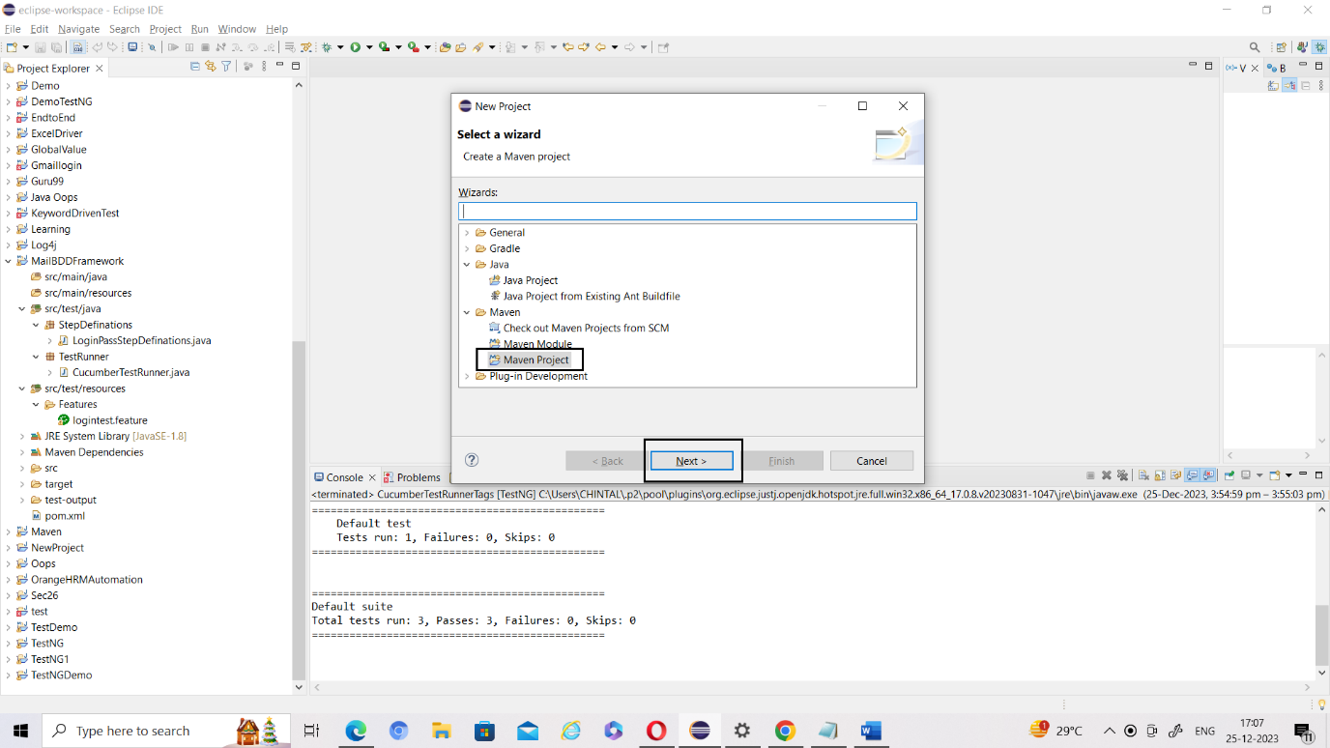

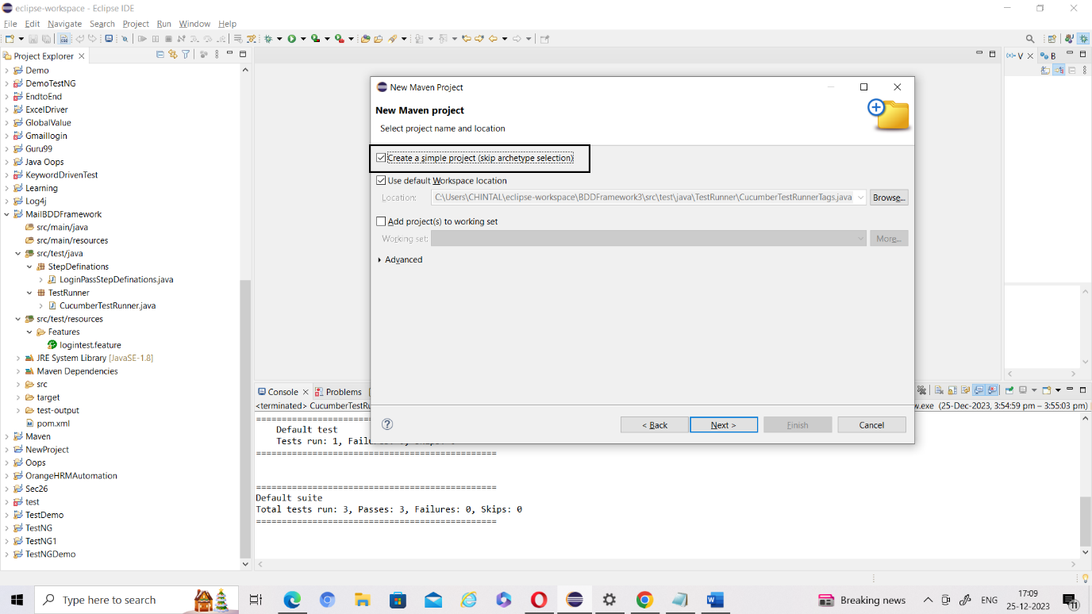

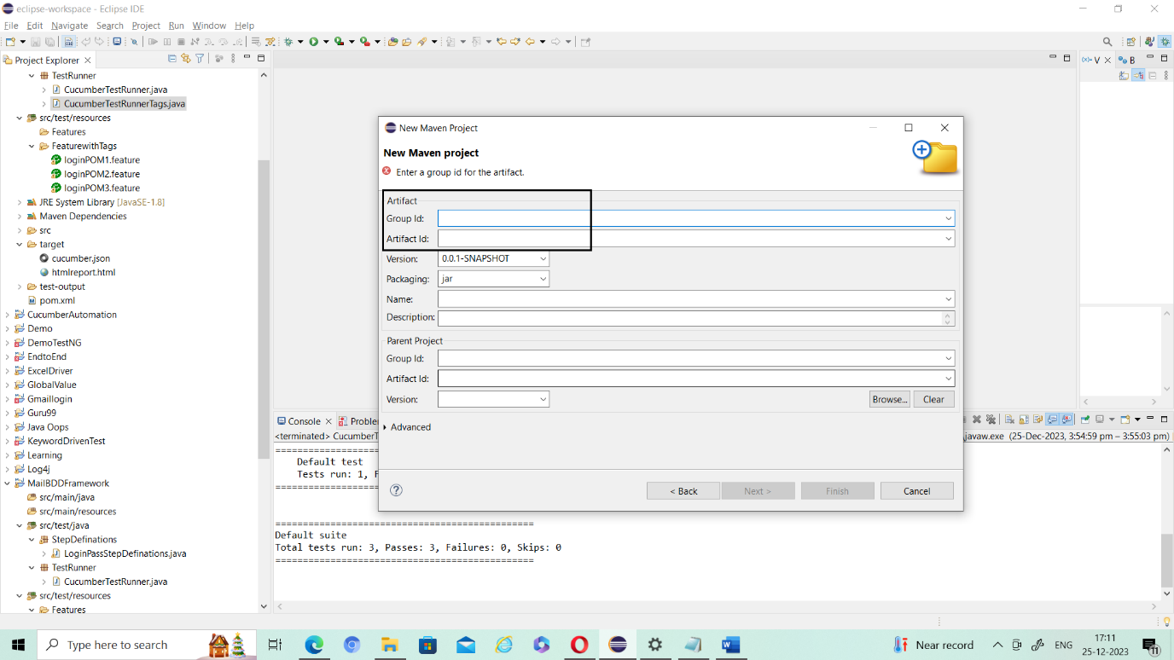

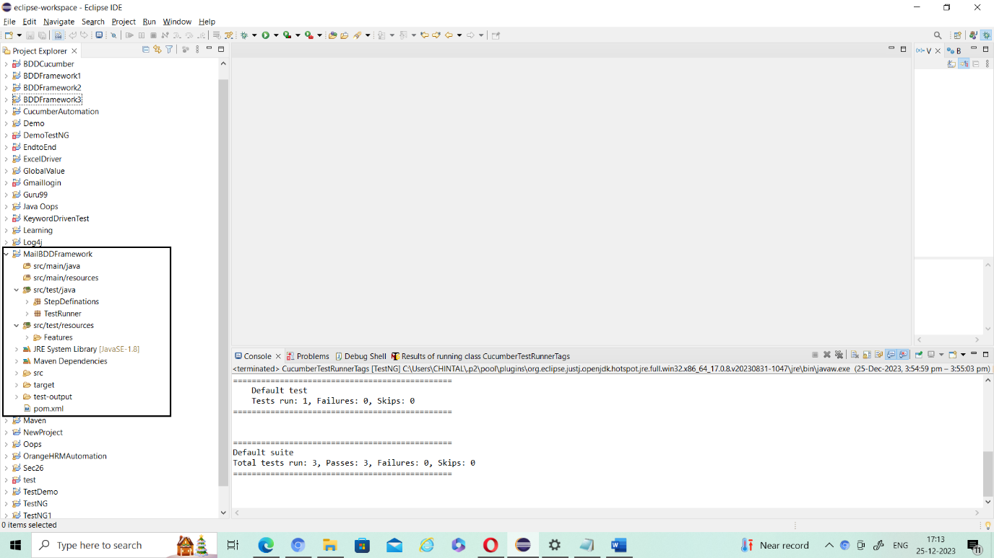

1. Click on Help 🡪 Eclipse Marketplace
2. Search Cucumber & TestNG
3. Install it

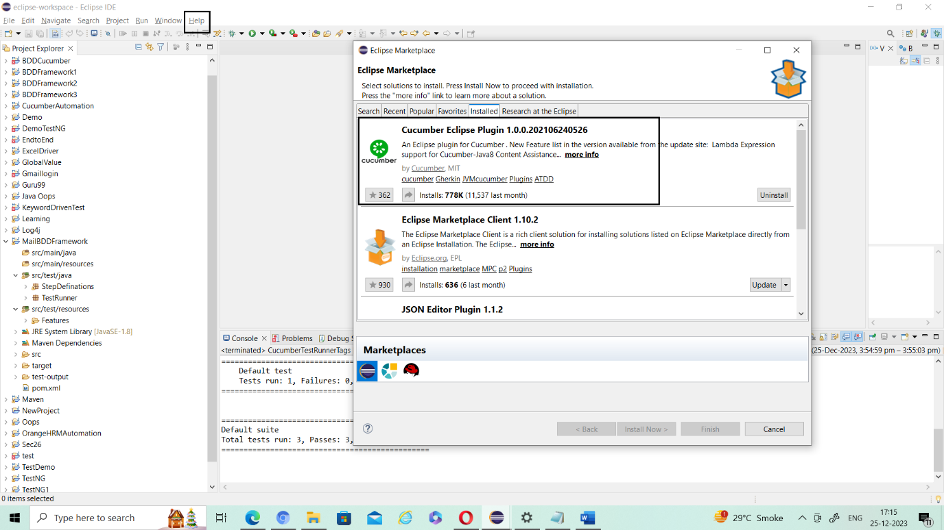

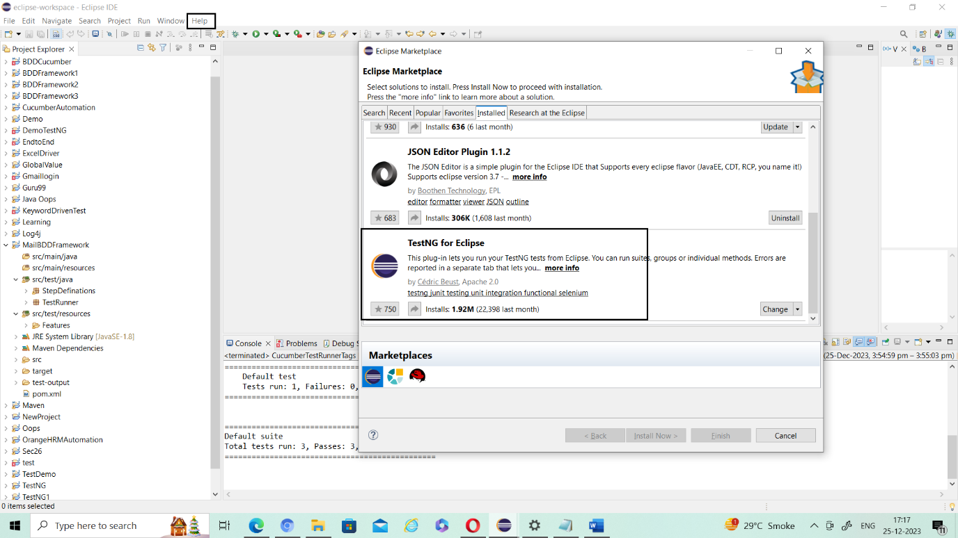

1. Now click on POM.xml file & open it
2. In Google search Maven Repository
3. Cucumber Java
4. Cucumber Testng
5. TestNG
6. Selenium Java
7. Create Feature file
8. src/test/resource 🡪 Create New **Folder** (Folder name Feature)
9. Under Feature 🡪 Create file 🡪 with extension .feature (login.feature)

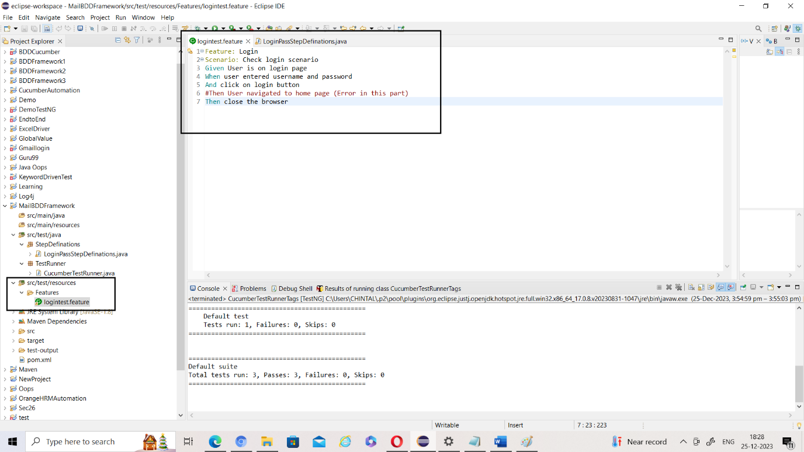

1. Run Cucumber file with Run Configuration, check its path

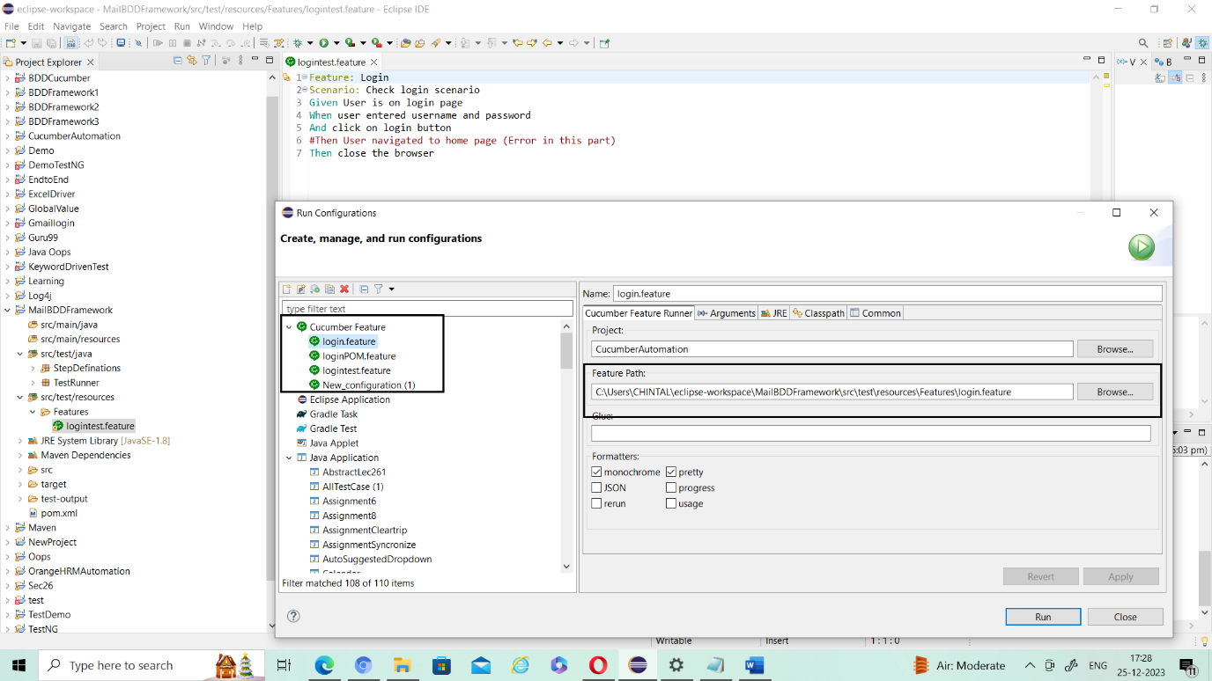

1. Create StepDefination.java File, for that
2. Src/test/java 🡪 Create new Pkg (Name StepDefinations)
3. In Created Pgk 🡪 Create new Class (Name LoginPassStepDefinations)

Here all you have to define all scenarios which define in. feature file.

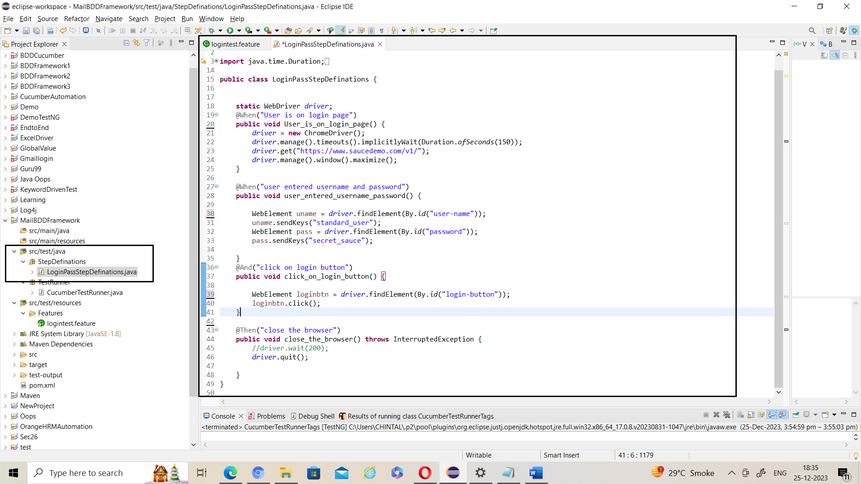

1. Create TestRunner.java File, for that
2. Src/test/java 🡪 Create new Pkg (Name TestRunner)
3. In Created Pgk 🡪 Create new Class (Name CucumberTestRunner)

Here you need to set path for feature, glue & can add html report as well.

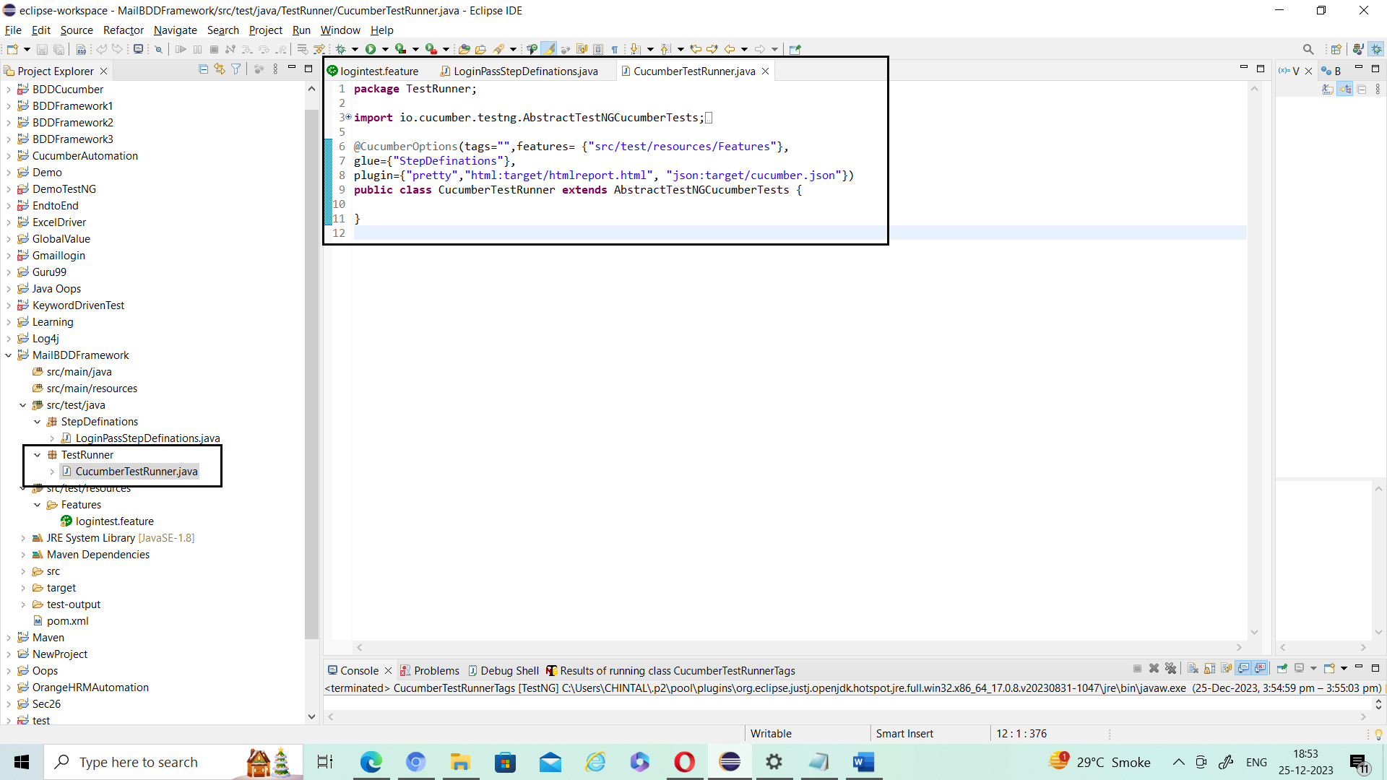

Now run from here using Run As 🡪 TestNG Test.

Enjoy 😊

Useful Link:

<https://www.youtube.com/watch?v=TYDTdODJ3Ig&list=PLxD77px6418Xjdme8VHlxy15qc038DQmt&index=5>

**Cucumber using BDD Framework**

**(**Multiple user Login (Parameterization & Data Driven Testing)**):**

Created BDDFramework1

Steps are same as above, just need to change in

Feature & StepDefination files.

.Feature file changes like,

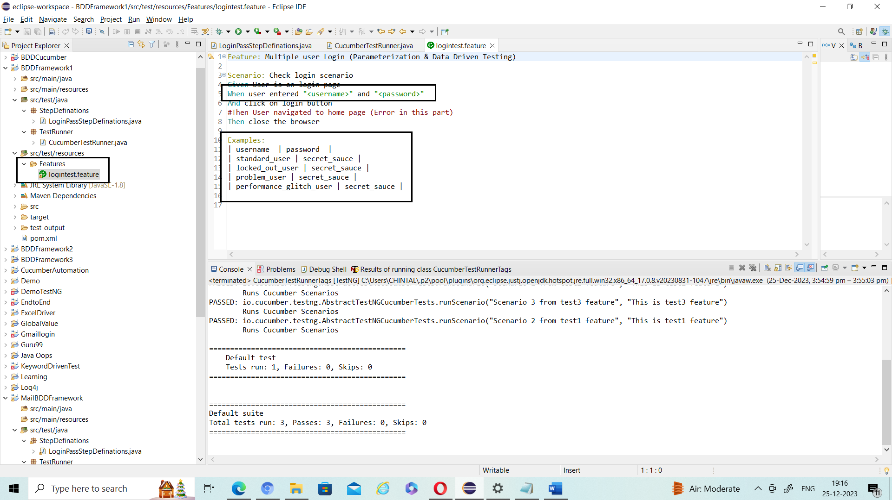

Now StepDefination file need to change as,

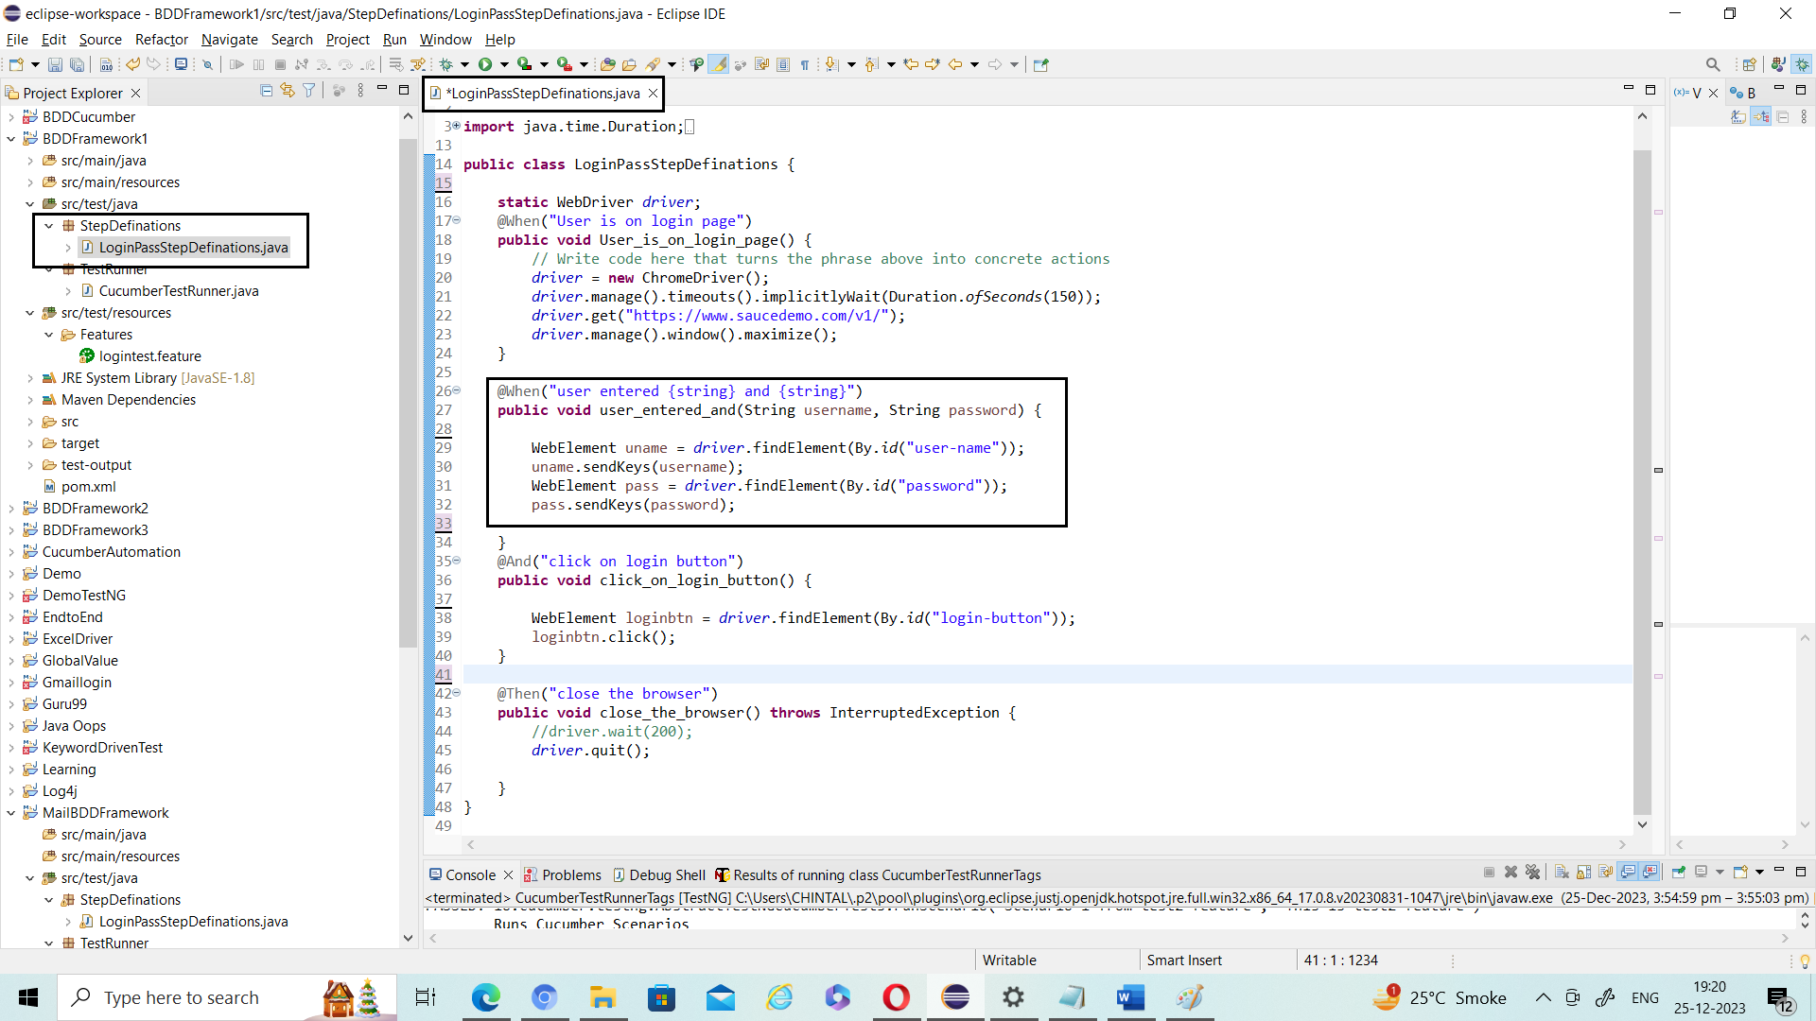

No need to change in TestRunner file.

Created BDDFramework1 project for

* Single user, POM: Page Object Model (Main File Read Again)

**Cucumber using BDD Framework**

**(**Multiple tags, some specific task need to perform**):**

Created BDDFramework3

Steps are same as above, just need to change in

Feature & Runner files.

.Feature file changes like,

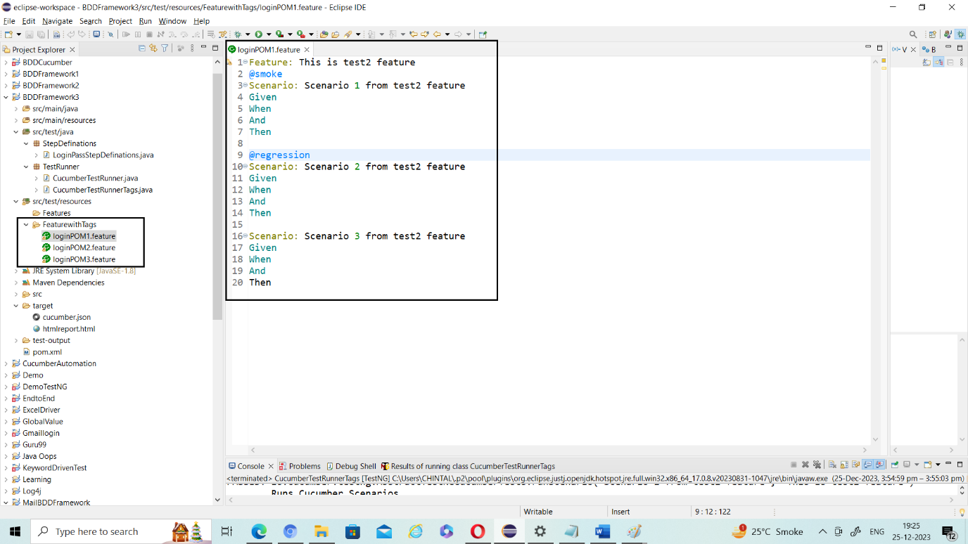

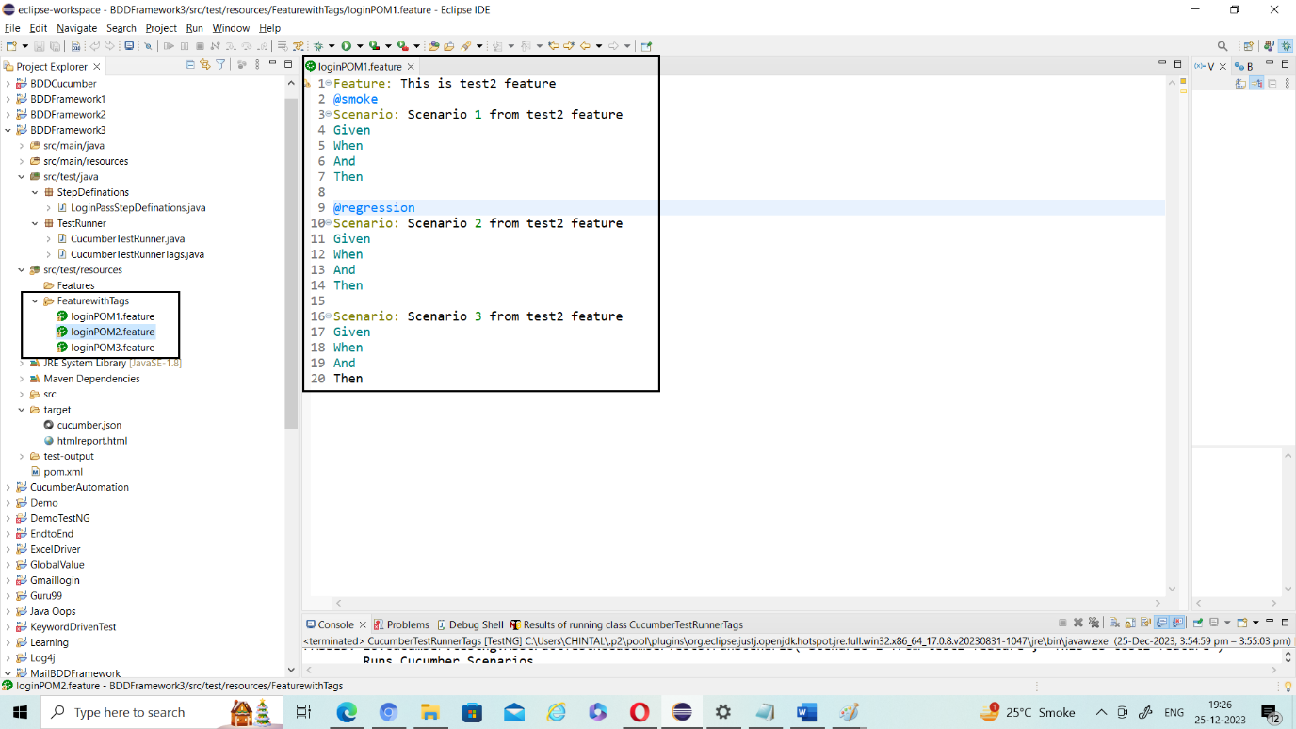

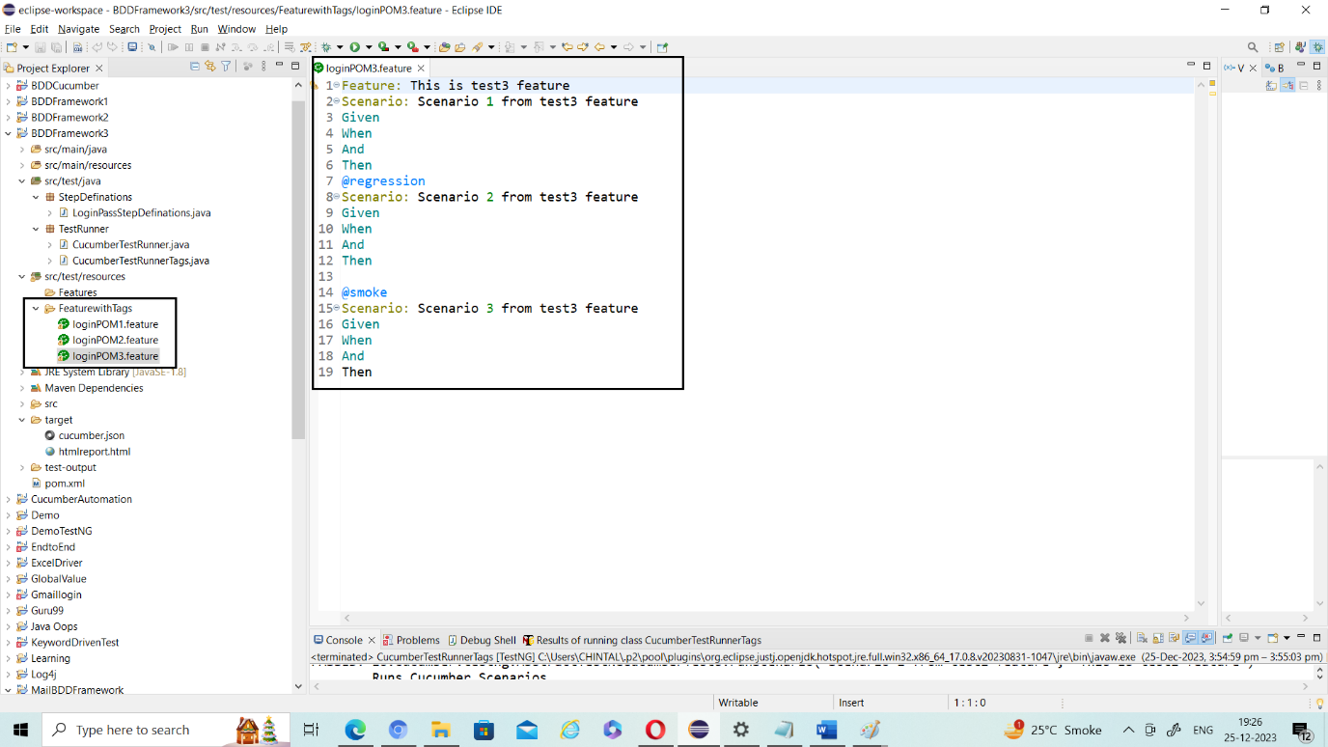

TestRunner file changes like,

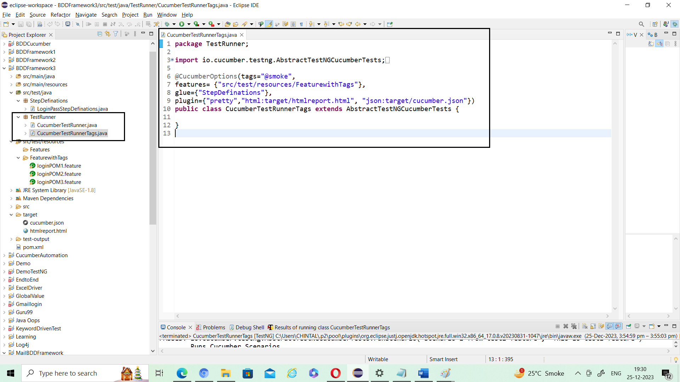

**How to Add Screenshot for fail scenario:**

Write basic script or above script code.

@After

**public** **void** teardown(Scenario sc)

{

System.***out***.println("Tear Down method executed");

**if**(sc.isFailed()==**true**)

{

String fileWithPath="C:\\Users\\CHINTAL\\eclipse-workspace\\BDDFramework4\\Screenshot.fail.png";

TakesScreenshot srcShot=((TakesScreenshot)*driver*);

File SrcFile=srcShot.getScreenshotAs(OutputType.***FILE***);

File DestFile=**new** File(fileWithPath);

**try** {

FileUtils.*copyFile*(SrcFile, DestFile);

} **catch** (IOException e) {

// **TODO** Auto-generated catch block

e.printStackTrace();

}

}

